5. BACKGROUND DATA 5-1
ADJUSTMENT TYPES 5-1
Adding Adjustment Types 5-1
Viewing Adjustment Types 5-2
Method 1 5-2
Method 2 5-2
Editing Adjustment Types 5-2
Deleting Adjustment Types 5-3
PRODUCTS MENU 5-3
CATEGORIES 5-3
ADDING CATEGORIES 5-4
Viewing Categories 5-5
Method 1 5-5
Method 2 5-5
Editing Categories 5-5
Deleting Categories 5-6
Printing the Selected Category 5-6
PRODUCTS 5-6
Adding Products 5-7
Shipments 5-8
Minimum Shipments 5-8
Shipment Volumes 5-8
Categories 5-9
Viewing Products 5-9
Method 1 5-9
Method 2 5-10
Editing Products 5-10
Deleting Products 5-10
Printing the Selected Product 5-10
CATEGORY AND PRODUCT ORDER 5-10
Viewing Category and Product Order 5-11
Setting the Order of Categories 5-11
Setting the Order of Categories 5-11
Setting the Order of Products 5-12
DISTRIBUTION LEVELS 5-12
Adding Distribution Levels 5-12
Viewing Distribution Levels 5-13
Method 1 5-13
Method 2 5-13
Editing Distribution Levels 5-14
Deleting Distribution Levels 5-14
Printing the Selected Distribution Level 5-14
Facilities Menu 5-15
Facility Types 5-15
Adding Facility Types 5-15
Adding Products to Facility Types 5-16
Removing Products from Facility Types 5-17
Viewing Facility Types 5-17
Method 1 5-17
Method 2 5-17
Editing Facility Types 5-18
Deleting Facility Types 5-18
Printing the Selected Facility Type 5-19
Facility Type Groups 5-19
Adding Facility Type Groups 5-20
Viewing Facility Type Groups 5-20
Method 1 5-20
Method 2 5-21
Editing Facility Type Groups 5-21
Editing Facility Types In a Group 5-21
Deleting Facility Type Groups 5-21
Printing the Selected Facility Type Group 5-22
Facilities 5-22
Adding Facilities 5-23
Maximum/Minimum Stock Levels 5-24
Viewing Facilities 5-26
Method 1 5-26
Method 2 5-26
Method 3 5-26
Editing Facilities 5-27
Deleting Facilities 5-27
Printing the Selected Facility 5-27
Purpose Of Use 5-28
Adding Purpose of Use 5-28
Viewing Purpose of Use 5-29
Method 1 5-29
Method 2 5-29
Editing Purpose of Use 5-29
Deleting Purposes of Use 5-29
Reporting GROUPS 5-30
Creating a Reporting Group 5-31
Method 1 5-33
Method 2 5-33
Editing Reporting Groups 5-33
Method 1 5-33
Method 2 5-34
Deleting a Reporting Group 5-34

FILE IS C:\WORK\SCMgr\Documents\new manual\SCMgr-sec5.doc

This is an information page. Do not include it in the finished manual.

BACKGROUND DATA
- In the main menu, click the Background Data option.

ADJUSTMENT TYPES
The Adjustment Types form lets you add or modify types of adjustments to inventory, which credit or debit a facility’s stock on hand. Adjustment codes and their descriptions refer to nonstandard movement of stock such as losses, transfers, loans, and expiration. (Regular receipts and issues are not adjustments.)
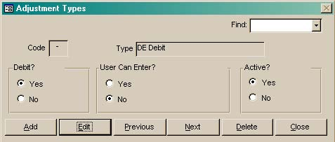
Figure 5-1 – Adjustment Types form

- In the Background Data menu, click the Adjustment Types option.

The Adjustment Types form (Figure 5-1) is displayed.

 | If adjustment types come from paper-based logistical reports, changes made to the adjustment types in Supply Chain Manager must correspond with the paper-based reports.

Adding Adjustment Types
- Click Add.
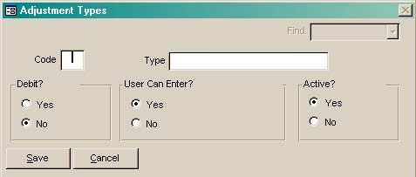
Figure 5-2 – Blank Adjustment Types form
A blank Adjustment Types form (Figure 5-2) is displayed.

- Type a code for the adjustment type (one letter or number) and press <Enter>.

- Type a name for the adjustment type.

- Click Yes in the Debit area if the code represents a debit (stock reduction). Skip this field if the code represents a credit (stock increase).

- Click No in the User Can Enter area if you do not wish users to record this type of adjustment. Skip this field if users are able to add, enter and delete adjustments of this type.

- Click Save.

- Repeat steps 1-6 to add more adjustment types.

- Click Close when you finish adding adjustment types.
 | DE Credit (positive adjustment) and DE Debit (negative adjustment) are computer-generated adjustments used by Supply Chain Manager to ensure that all reported figures are in balance.

Viewing Adjustment Types

Method 1
- Click on the arrow to the right of the Find field, select an adjustment type from the pull-down menu, and click the left mouse button to display the adjustment type you selected.

Method 2
- Click Next to display the next adjustment type.

- Click Previous to display the previously displayed adjustment type.

- Click Close when you finish viewing adjustment types.

Editing Adjustment Types
- Select the adjustment type you wish to edit.

- Click Edit.

- Click on the field you wish to edit and type your changes.

- If the adjustment type is no longer active, click the Active checkbox to remove the checkmark.

- Click Save.

- Repeat steps 1-5 to edit additional adjustment types.

- Click Close when you finish editing adjustment types.

 | You cannot delete adjustment Types for adjustments that have been recorded in the Product Tracking form.

Deleting Adjustment Types
- Select the adjustment type you wish to delete.
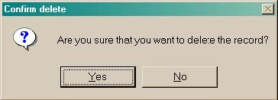
Figure 5-3 – Delete confirmation message
- Click Delete.

A confirmation message (Figure 5-3) is displayed, asking you to confirm the delete.

- Click Yes to delete the selected record. Click No to cancel.

- Click Close when you finish deleting adjustment types.

PRODUCTS MENU
- In the main menu, click the Products option.

CATEGORIES

 | You can categorize products by health programs if you associate products with programs. For example, you can categorize condoms under the AIDS prevention program, if condoms are distributed for that purpose. You can also associate one product with multiple health programs.
The Categories form lets you group similar products. Grouping products is necessary for forecasting in order to plan and allocate resources to prevent stockouts.

- In the Products menu, click the Categories option.

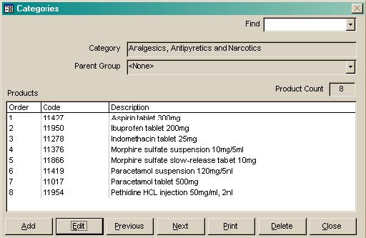
Figure 5-4 – Categories formThe Categories form (Figure 5-4) is displayed.

ADDING CATEGORIES
- Click Add.

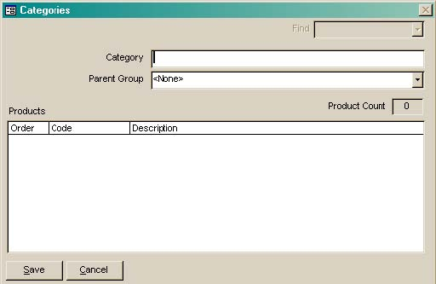
Figure 5-5 – Blank Categories formA blank Categories form (Figure 5-5) is displayed.

 | After you add a category, you must use the Products form to associate products with the category. (See Adding Products on page 9 for more information.)
- Type the category name, and press <Enter>.

- Click on the arrow next to the Parent Group field, select a parent category from the list, and click the left mouse button.

If no other categories exist, leave the parent category field blank.

- Click Save.

- Repeat steps 1-4 to add more categories.

- Click Close when you finish adding categories.

Viewing Categories

Method 1
- Click on the arrow next to the Find field, select a category from the pull-down menu, and click the left mouse button to display the selected category.

Method 2
- Click Next to display the next category.

- Click Previous to display a previously displayed category.

- Click Close when you finish viewing categories.

Editing Categories
- Select the category you wish to edit.

- Click Edit.

- Change the category name.
 | A category can be deleted only when all of its products are deleted or associated with a different category. See Deleting Products on page 14 and Editing Products on page 13 for information on changing a product’s category.

- Click Save.

- Repeat steps 1-4 to edit additional categories.

- Click Close when you finish editing categories.

Deleting Categories
- Display the category you wish to delete, and click Delete.
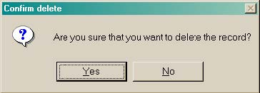
Figure 5-6 – Delete confirmation message
A confirmation message (Figure 5-6) is displayed, asking you to confirm the delete.

- Click Yes to delete the selected record.

- Repeat steps 1-3 to delete additional categories.

- Click Close when you finish deleting categories.

Printing the Selected Category
- Click Print to create a report for the selected category.

PRODUCTS
- In the Products menu, click the Products option.

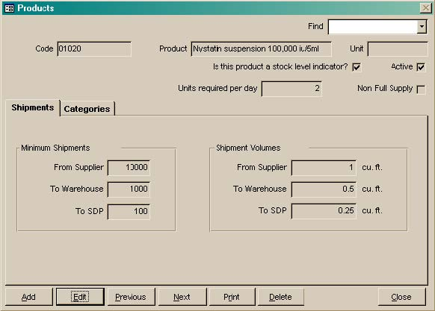
Figure 5-7 – Products formThe Products form (Figure 5-7) is displayed.

Adding Products
- Click Add.

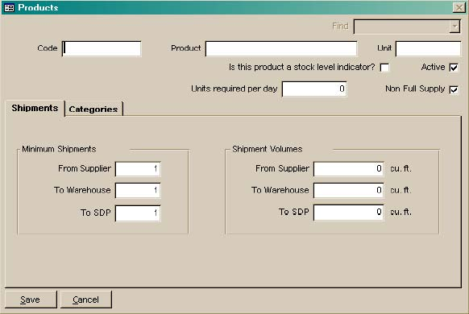
Figure 5-8 – Blank Products formA blank Products form (Figure 5-8) is displayed.

- Type the product code and press <Enter>.

- Type the product name and press <Enter>.

- Type the unit dose (if applicable) and press <Enter>.

Products that are marked as stock level indicators are used to measure the overall stock status of a particular facility. The DRP module calculates facility need based on the stock status of products that are stock level indicators. If you manage a distribution system with many products, you may choose to select only a handful of products as stock level indicators.

- Click the Stock Level Indicator field if the product is a stock level indicator.

The Active f lag indicates that the product is currently distributed. By default, Supply Chain Manager marks all new products as active.

The Units Required Per Day field records the number of units of the product (tablets, bottles, etc.) that must be used by a patient each day. If the number of units required per day is less than one, enter a fraction (for example, 0.25) in this field. The number of units required per day is used by Supply Chain Manager to calculate the number of products required for new patients. See Product Tracking on page 6-1 for more information.

- Type the number of units of the product that must be used by a patient each day and press <Enter>.

Some products are not in full supply and are ordered by facilities sporadically. The Non Full Supply field is used to indicate that a product is not kept in full supply. For products that are marked non full supply, Supply Chain Manager does not calculate or display required order quantities to bring the products up to the established maximum stock level.

- Click the Non Full Supply field if the product is not kept in full supply.

Shipments
The Minimum Shipments area lets you indicate the minimum amount that can be shipped from the supplier, to storage facilities and to SDPs. The Shipment Volumes area lets you indicate the volume of a single shipment unit for each product. Shipment volume is used by the DRP module to calculate how much of the product will fit on a delivery vehicle.
 | Shipment volumes are used by the DRP module to calculate delivery loads. You may leave the shipment volume fields blank if you are not using DRP.

Minimum Shipments
- Click the From Supplier field, type the minimum amount that can be received from the supplier, and press <Enter>.

- Type the minimum amount to be distributed to each warehouse and press <Enter>.

- Type the minimum amount to be delivered to each SDP and press <Enter>.

Shipment Volumes
- Type the size of a single shipment unit sent by the supplier and press <Enter>.

- Type the size of a single shipment unit sent to each warehouse and press <Enter>.

- Type the size of a single shipment unit sent to each SDP.

Categories
The Categories tab lets you assign the product to one or more existing categories.

- Click the Categories tab.

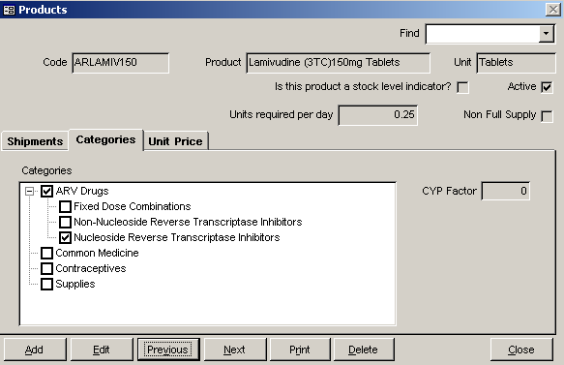
Figure 5-9 -- Categories tab in Products formThe list of categories (Figure 5-9) is displayed.

- Click the left mouse button on one or more categories to place a checkmark in the box to the left of each category.
 | The CYP Factor field lets you indicate the couple-year protection factor for a product. This field applies only to contraceptives.

- Type the CYP factor in months (if applicable).

- Click Save.

- Click close when you finish adding products.

Viewing Products

Method 1
- Click on the arrow next to the Find field, select a product from the pull-down menu, and click the left mouse button to display the product.

Method 2
- Click Next to display the next product.

- Click Previous to display the previously displayed product.

- Click Close when you finish viewing products.

Editing Products
- Select the product you wish to change.

- Click Edit.

- Click on the field you wish to change and type your changes.

- If the product is no longer active, click the Active field to remove the check mark.

- Click Save.

- Click Close when you finish editing products.

Deleting Products
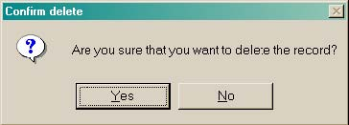
- Figure 5-10 – Delete confirmation messageSelect the product you wish to delete and click Delete.

A confirmation message (Figure 5-10) is displayed, asking you to confirm the delete.

- Click Yes to delete the record.

- Repeat steps 1-3 to delete additional products.

- Click Close when you finish deleting products.

Printing the Selected Product
- Click Print to create a report for the selected product.

CATEGORY AND PRODUCT ORDER
The Category and Product Order form lets you set the order that categories and products will appear on the Product Tracking form and in reports. You can set the order in which categories and products are displayed in Supply Chain Manager according to the format of paper-based forms or reports in the distribution system. As the distribution system expands to include additional health programs, you can add each health program’s categories to Supply Chain Manager and order the products in each category.

Viewing Category and Product Order
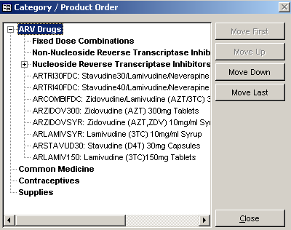
Figure 5-11 – Category/Product Order formThe list of categories, subcategories and products in Supply Chain Manager is displayed in a tree menu on the Category/ Product Order form (Figure 5-11).

You can expand or contract each category in the list by clicking on the plus or minus sign to the left of the category. When you expand a category, all subcategories and products are displayed. When you contract a category, the subcategories and products are hidden from view.

Setting the Order of Categories
You can move categories within the entire list of categories. When you move a category, you also move the subcategories and products associated with that category. Categories and products are then displayed in the same order in the Product Tracking form.

- In the Products menu, select Category/Product Order.

Setting the Order of Categories
You can move categories within the entire list of categories. When you move a category, you automatically move all the subcategories and products associated with that category. Categories and products are then displayed in the same order in the Product Tracking form.

- In the Products menu, select Category/Product Order.

The Category/Product Order form is displayed as shown in Figure 5-11 above.

- Click a category you want to move.

- Click Move Up or Move Down to move the category up or down one position.

- Click Move First or Move Last to move the category to the first or last position.

- Click Close when you finish setting the order of categories.

Setting the Order of Products
You can also move individual products within each category.

- Click a product you want to move.

- Click Move Up or Move Down to move the product up or down one position within the category.

- Click Move First or Move Last to move the product to the first or last position within the category.

- Click Close when you finish setting the order of products.

DISTRIBUTION LEVELS
The Distribution Levels form lets you define the distribution levels in the system. The table below lists sample distribution levels.

Distribution Level | Definition
Central | Top of the distribution hierarchy. This facility supplies other facilities.
District | Middle of the distribution hierarchy. This facility receives supplies from the central facility and distributes to lesser facilities.
SDP | Bottom of distribution hierarchy. This facility receives supplies from the district facility and distributes to end users.

- In the Background Data menu, click the Distribution Levels option.

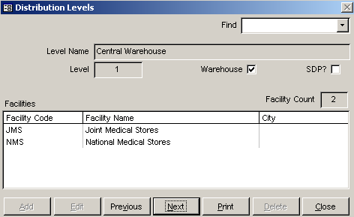
Figure 5-12 – Distribution Level formThe Distribution Levels form (Figure 5-12) is displayed.

Adding Distribution Levels
- Click Add.

A blank Distribution Levels form is displayed as shown in Figure 5-13 on the following page.

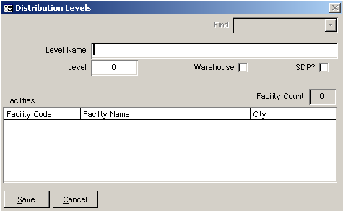
- Figure 5-13 – Blank Distribution Levels formType a name for the distribution level and press <Enter>.

The Level field lets you indicate a distribution level’s position within the distribution network. Distribution levels use numerical values to denote each position, with one (1) as the highest level.

- Type the number representing the distribution level.

- Click the Warehouse checkbox if the distribution level represents a storage facility.

- Click the SDP checkbox if the distribution level represents an SDP.

- Click both Warehouse and SDP checkboxes if the distribution level represents a storage facility that also acts as an SDP.
 | Facilities are assigned to a distribution level in the Facilities form. See Editing Facilities on page 35 for more information.

- Click Save.

- Repeat steps 1-7 to add more distribution levels.

- Click Close when you finish adding distribution levels.

Viewing Distribution Levels

Method 1
- Click on the arrow next to the Find field, select a distribution level from the pull-down menu, and click the left mouse button to display the selected distribution level.

Method 2
- Click Next to display the next distribution level.

- Click Previous to display the previously displayed distribution level.

- Click Close when you finish viewing distribution levels.

Editing Distribution Levels
- Select the distribution level you wish to edit.

- Click Edit.

- Click on the field you wish to change and type your changes.

- Click Save.

- Repeat steps 1-4 to edit additional distribution levels.

- Click Close when you finish editing distribution levels.

Deleting Distribution Levels
 | A distribution level can only be deleted after all its facilities are deleted or associated with a different distribution level. (See Deleting Facilities on page 35 and Editing Facilities on page 35 for more information.)

- Select the distribution level you wish to delete.

- Figure 5-14 – Delete confirmation messageClick Delete.

A confirmation message (Figure 5-14) is displayed, asking you to confirm the delete.

- Click Yes to delete the selected record.

- Repeat steps 1-4 to delete additional distribution levels.

- Click Close when you finish deleting distribution levels.

Printing the Selected Distribution Level
- Click Print to create a report for the selected distribution level.

Facilities Menu
In the main menu, click the Facilities option.

Facility Types
The Facility Types form lets you classify the facilities in the distribution system. Distinguishing facility types facilitates forecasting, which allows you to plan and allocate resources to prevent stockouts.

- Click the Facility Types option.

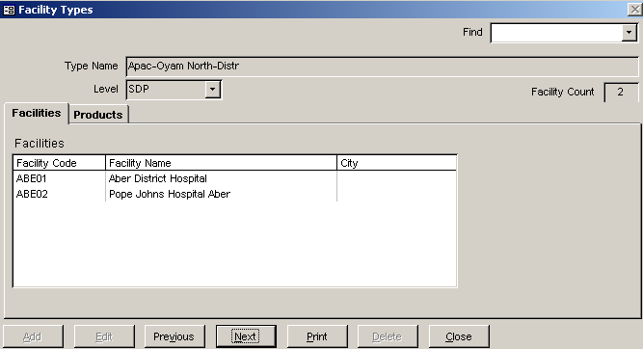
Figure 5-15 – Facility Types formThe Facility Types form (Figure 5-15) is displayed.

Adding Facility Types
- Click Add.

A blank Facility Types form (Figure 5-16) is displayed as shown on the following page.

- Type the facility type name.

The Level field lets you indicate the facility type’s position in the distribution network. Distribution levels listed in this field are the ones you entered in the Distribution Levels form.

- Click on the arrow next to the Level field, select a distribution level from the pull-down menu, and click the left mouse button.
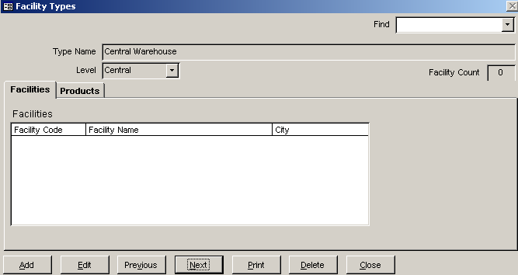
Figure 5-16 – Blank Facility Types form

 | Facilities are assigned to a facility type in the Facilities form. (See Editing Facilities on page 35 for more information.)

Adding Products to Facility Types
You can assign products to a facility type in the Products tab. The products you assign to a facility type are the ones facilities belonging to that facility type can stock and dispense. For example, a program for HIV/AIDS care and treatment may have a limited number of facilities that are capable of providing antiretroviral therapy. Therefore, antiretroviral drugs would be assigned to a facility type designated as an ART (antiretroviral therapy) service site.

- Click the Products tab.

The list of products (Figure 5-17 on the following page) is displayed.

- In the Available Products area, click the product you want to assign to this facility type. Select multiple products by pressing <Ctrl> as you click on each product.

- Click the right arrow to move the selected product to the Issued Products area.
 | If the Products tab does not list products, you must first add products. (See Adding Products on page 9 for more information.)

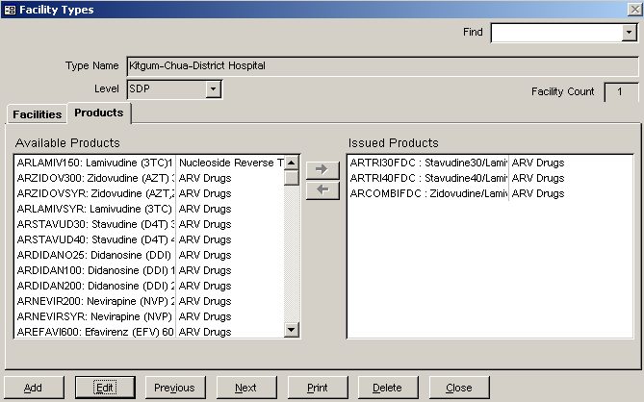
Figure 5-17 – Product list in Facility Type form

- Repeat steps 5-6 to add more products to the facility type.

- Click Save.

- Click Close when you finish adding facility types.

Removing Products from Facility Types
- In the issued products area, click the product you want to remove from the facility type.

- Click the left arrow to move the selected products to the Available Products area.

Viewing Facility Types

Method 1
- Click on the arrow next to the Find field, select a type from the pull-down menu, and click the left mouse button to display the selected facility type.

Method 2
- Click Next to display the next facility type.

- Click Previous to display the previously displayed facility type.

- Click the Products tab to view products that are associated with the selected facility type.

- Click Close when you finish viewing facility types.

Editing Facility Types
- Select the facility type you wish to edit.

- Click Edit.

- Click on the field you wish to change and type your changes.

- Click the Products tab to add or remove products.

- Click the product(s) you wish to add to or remove from the facility type.

- Click the right arrow or left arrow to add the product to or remove the product from the facility type.

- Repeat steps 1-6 to edit additional facility types.

- Click Save.

- Click Close when you finish editing facility types.

Deleting Facility Types
- Select the facility type you wish to delete.

If the selected facility type has associated facilities, you must first delete or reassociate the facilities.
Figure 5-18 – Delete confirmation message
- Click Delete.

A confirmation message (Figure 5-18) is displayed, asking you to confirm the delete.

- Click Yes to delete the selected record.

Repeat steps 1-4 to delete additional facility types.

- Click Close when you finish deleting facility types.

Printing the Selected Facility Type
- Click Print to create a report for the selected facility type.

- After the report is created and the first page is displayed, click the Print icon to print the report.

- Click Close in the print menu to return to the Facility Types form.

- Click Close when you finish printing facility types.

Facility Type Groups
Use the Facility Type Groups form to group facility types. This feature allows you to group two or more facility types in order to view aggregated data on the stock status and performance of these facilities. For example, based on the information needs of program managers, facility type groups may be created according to the types of services each facility type offers. Examples include facilities that offer antiretroviral therapy (ART) services or facilities that offer Norplant®. Grouping several facility types in this way helps to identify facilities that provide special services and the unique products associated with those services.

- Click the Facility Type Groups option.
 | A facility type can be deleted only after all associated facilities are deleted or associated with a different facility type. (See Deleting Facilities on page 35 and Editing Facilities on page 35 for more information.)

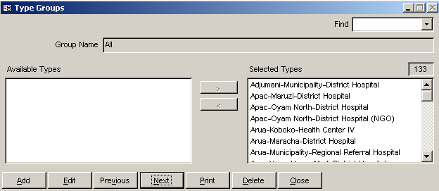
Figure 5-19 – Facility Type Groups formThe Facility Type Groups form (Figure 5-19) is displayed.

Adding Facility Type Groups
- Click Add.

A blank Facility Type Groups form (Figure 5-20) is displayed.
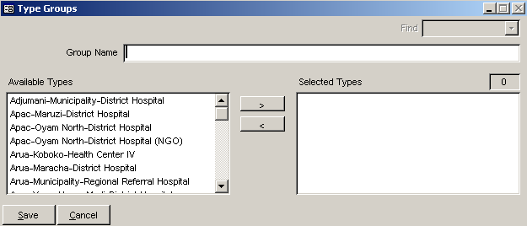
Figure 5-20 – Blank Facility Type Groups form

- Type the facility type group name.

- Click Save.

- After you save the group name, click Edit to add facility types.

- Select one or more facility types in the Available Types window and click Add.

- Click Save.

- Repeat steps 1-6 to add more facility type groups.

- Click Close when you finish adding facility type groups.

Viewing Facility Type Groups

Method 1
- Click on the arrow next to the Find field, select a group from the pull-down menu, and click the left mouse button to display the selected group.

Method 2
- Click Next to display the next group.

- Click Previous to display the previously displayed group.

- Click Close when you finish viewing facility type groups.

Editing Facility Type Groups
- Select the facility type group you wish to change.

- Click Edit.

- To change the facility type group name, type the group name in the Group Name field.

Editing Facility Types In a Group
- To remove a facility type from the group, click the facility type in the Selected Types window and click the left arrow.

- To add a facility type to the group, click the facility type in the Available Types window and click the right arrow.

- Click Save.

- Repeat steps 1-4 to change add facility types to or remove facility types from a group.

- Click Close when you finish editing facility type groups.

Deleting Facility Type Groups
- Select the facility type group you wish to delete.

- Figure 5-21 – Delete confirmation messageClick Delete.

A delete confirmation message (Figure 5-21) is displayed, asking you to confirm the delete.

- Click Yes to delete the selected record.

- Repeat steps 1-4 to delete additional facility type groups.

 | To select more than one facility type, hold down the <Ctrl> or <Shift> keys while clicking the facility type name.

- Click Close when you finish deleting facility type groups.

Printing the Selected Facility Type Group
- Click Print to create a report for the selected group.

- After the report is created and the first page is displayed, click the Print icon to print the report.

- Click Close on the Print Menu to return to the Facility Type Group form.

- Click Close when you finish printing the selected facility type group.

Facilities
- In the Facilities menu, click the Facilities option.

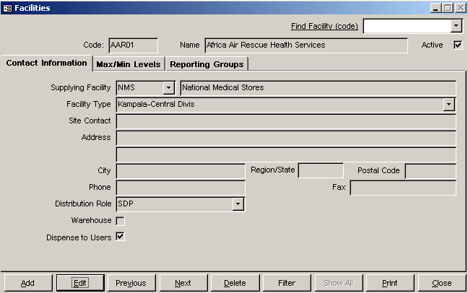
Figure 5-22 –Facilities formThe Facilities form (Figure 5-22) is displayed.

Adding Facilities
- Click Add.

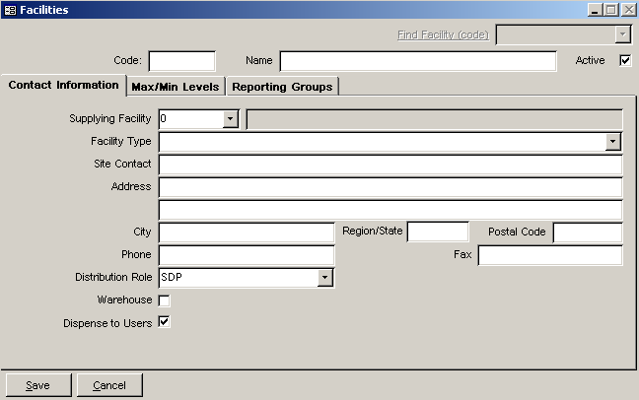
Figure 5-23 – Blank Facilities formA blank Facilities form (Figure 5-23) is displayed.

Each facility requires a unique facility code.

- Type a unique code and press <Enter>.

- Type the facility name and press <Enter> twice.

The Supplier field indicates the facility that distributes products to the current facility. In the case of a central storage facility, the supplier is always zero (0), indicating that the supplier is outside the distribution system.

- Click on the arrow next to the Supplier field, select a supplying facility from the pull-down menu, and click the left mouse button.

The Active field indicates that the facility is currently part of the distribution system. New facilities are active by default.

- Click on the arrow next to the Facility Type field, select a type from the pull-down menu, and click the left mouse button.

The Site Contact field identifies the facility’s contact person.

- Type the contact person’s name and press <Enter>.

The Address, City, Region/State and Zip Code fields are for the facility’s address.

- Type the facility’s address and press <Enter>.

- Type the facility’s phone number and press <Enter>.

- Type the facility’s fax number and press <Enter>.

The Distribution Level field lets you indicate the facility’s position in the distribution network. These levels are established in Adding Distribution Levels on page 17.

- Click on the arrow next to the Distribution Level field, select a distribution level from the pull-down menu, and click the left mouse button.

The Warehouse checkbox indicates that the facility is a storage facility. In most cases, central- and district-level facilities are warehouses (an SDP can be a warehouse, even though it distributes to end users). By default, the Warehouse checkbox is unchecked to show that the facility is not a warehouse.

- Click the Warehouse checkbox if the facility is a warehouse.

The Dispense To Users checkbox indicates that the facility distributes to end users. By default, the Dispense to Users checkbox is checked.

- Click the Dispense to Users checkbox to remove the check if the facility does not distribute to end users.

Maximum/Minimum Stock Levels
The Max/Min Levels tab (if enabled) lets each facility in your system define a maximum and minimum stock level for each product category.

- Click on the Max/Min Levels tab.

The Max/Min Levels form is displayed as shown in sample Figure 5-24 on the following page.
 | Make sure to add the top-level storage facility first. The top-level storage facility is directly and indirectly responsible for supplying all other facilities in the distribution network. Always add facilities from the top down (for example, central facilities first, district facilities second, SDPs third). This lets you select the supplying facility as you add each facility.

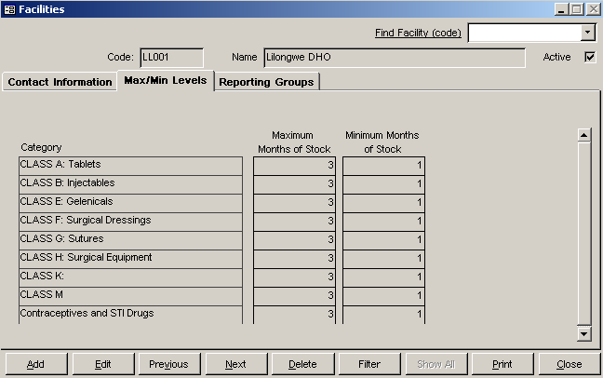
Figure 5-24 – Sample Max/Min Levels tab

Minimum and maximum months of stock describe the stock level a facility should maintain. These values show the maximum allowable stock level a facility can have and the minimum level a facility can reach before needing re-supply.

For example, SDPs may require a maximum of three months’ worth of supplies and a minimum of one month. A central warehouse may need a maximum of six months’ worth of supplies and a minimum of three months.

- Click the Maximum Stock in MOS field and type the maximum stock level in months.

- Click the Minimum Stock in MOS field and type the minimum stock level in months.

- Click Save.

- Repeat steps 1-16 to add facilities.

- Click Close when you finish adding facilities.

Viewing Facilities

Method 1
- Click on the arrow next to the Find facility field, select a facility from the pull-down menu, and click the left mouse button to display the selected facility.

Method 2
- Click Next to display the next facility.

- Click Previous to display the previously displayed facility.

Method 3
- Click Filter.

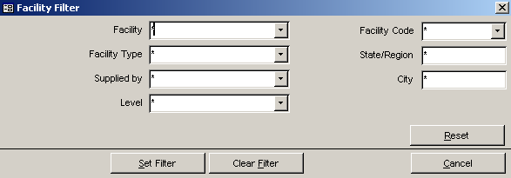
Figure 5-25 – Facility Filter formThe Facility Filter form (Figure 5-25) is displayed. This form displays search criteria you can use to find a particular facility.

- Click the arrow next to the filter(s) to search by, select an option from the pull-down menu and click the left mouse button.

- Click the State/Region and/or City fields and type of the name of the state/region or city to search by.

- Click Set Filter.

Facilities matching the search criteria are displayed in alphabetic order by facility name.

You can clear filter results and display all facilities by clicking Show All.

- Click Show All.

The first facility in the list of all facilities is displayed.

- Click Close when you finish viewing facilities.

Editing Facilities
- Select the facility you wish to edit.

- Click Edit.

- Click on the field you wish to change and type your changes.

- If the facility is no longer active, click the Active checkbox to remove the checkmark.

- Click Save.

- Repeat steps 1-5 to edit additional facilities.

- Click Close when you finish editing facilities.

Deleting Facilities

- Select the facility you wish to delete.

- Figure 5-26 – Delete confirmation messageClick Delete.

A confirmation message (Figure 5-26) is displayed, asking you to confirm the delete.

- Click Yes to delete the selected record.

- Repeat steps 1-3 to delete additional facilities.

- Click Close when you finish deleting facilities.

 | A facility cannot be deleted if it has product tracking records. An alert message is displayed if a facility cannot be deleted.

Printing the Selected Facility
- Click Print to create a report for the selected facility.

- After the report is created and the first page is displayed, click the Print icon to print the report.

- Click Close on the Print Menu to return to the Facility form.

- Click Close when you finish printing facilities.

Purpose Of Use
The Purpose of Use feature lets you indicate what purpose a product (or group of products) will be used for. This feature becomes available when the Purpose of Use field is checked during system maintenance. See Section 4 – System Maintenance for more information.

- In the Background Data menu, click the Purpose of Use option.

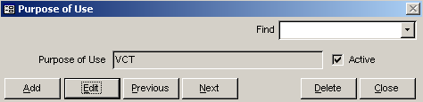
Figure 5-27 – Purpose of Use formThe Purpose of Use form (Figure 5-27) is displayed.

Adding Purpose of Use
- Click Add.

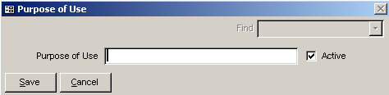
Figure 5-28 – Blank Purpose of Use formA blank Purpose of Use form (Figure 5-28) is displayed.

- Type a code or name for the purpose of use.

The Active field indicates that the purpose of use is currently in use.

- Click Save.

- Click Close when you finish adding purpose of use.

Viewing Purpose of Use

Method 1
- Click on the arrow next to the Find field, select a purpose of use from the pull-down menu, and click the left mouse button to display the selected purpose of use.

Method 2
- Click Next to display the next purpose of use.

- Click Previous to display the previously displayed purpose of use.

Editing Purpose of Use
- Select the purpose of use you wish to edit.

- Click Edit.

The Purpose of Use field will be selected for editing.

- Type any changes in the Purpose of Use field.

- If the purpose of use is no longer active, click the Active checkbox to remove the checkmark.

- Click Save.

- Repeat steps 1 – 5 to edit additional purposes of use.

- Click Close when you finish editing facilities.

Deleting Purposes of Use
- Select the purpose of use you wish to delete.

- Click Delete.

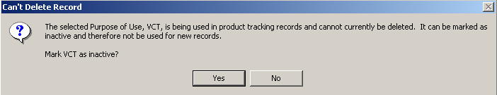
Figure 5-29 – Delete Purpose of Use alert messageIf there are product tracking records associated with the selected purpose of use, a message (Figure 5-29) is displayed, asking you to mark the purpose of use inactive.

- Click Yes to mark the selected purpose of use inactive.

Figure 5-30 – Delete confirmation messageIf there are no product tracking records associated with the selected purpose of use, a confirmation message (Figure 5-30) is displayed, asking you to confirm the delete.

- Click Yes to delete the selected purpose of use.

- Repeat steps 1 – 4 to delete additional purposes of use.

- Click Close when you finish deleting purposes of use.

Reporting GROUPS
The Reporting Groups feature helps you classify facilities as part of one of more groups for reporting purposes.

From the Background Data menu,

- Click on the Reporting Groups option.

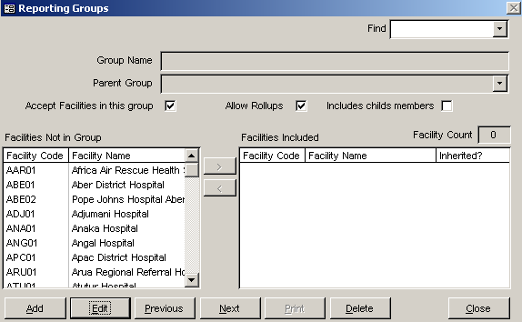
Figure 5-31 – Sample Reporting Groups formThe Reporting Groups form is displayed similar to the sample in Figure 5-31.

This form lets you create reporting groups and assign facilities to each group. You will also have the following options to apply to each group.

- Accept Facilities into this group:
Lets you determine if the group allows users to assign facilities to the group.

- Allow rollups:
Lets you determine if users are allowed to rollup reporting data based on the group. This feature, however, is currently unavailable.

- Include Child Members:
Lets you determine if the group will consider members of child groups as its members. (This allows for grouping of groups.) You should select this option if you have chosen not to allow rollups. (Allow Rollups field not selected.)

Creating a Reporting Group
- Click on the Add button.

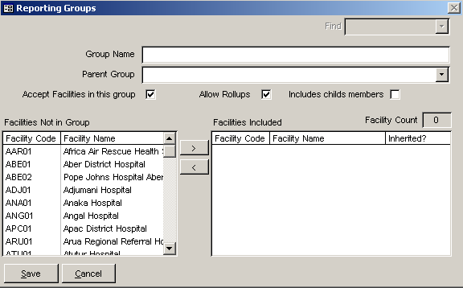
Figure 5-32 – Blank Reporting Groups formA blank Reporting Groups form in displayed similar to the sample in Figure 5-32.

- Click in the Group Name field and type the reporting group's name.

- Click in the Parent Group field and type the name of the reporting group's parent group.

 | If the reporting group will not have a parent group, select "<none>" from the Parent Group field's pull-down menu.
- Click in the Accept Facilities in This Group or Include Child's Members, or both ass needed.
These fields can be skipped if they do not apply to the reporting group you are creating.

The Facilities Included listbox shows all facilities considered part of the group.
 | If the ‘Inherited?’ column shows an ‘X’, the facility is a member of an included child group.

Facilities may be added to the Reporting group by selecting those listed in the Facilities not in Group listbox.

- Click on the facility in the facilities Not in Group listbox you want to make part of the group.

You can select multiple facilities at one time as follows:

Method 1
- Hold down the <CTRL> key and click on each facility you want to include.

- Click on the move button .

Method 2
- Click on the first facility you want to include.

- Scroll down to the last facility you want to include.

- Hold down the <Shift> key and click on the last facility you want to include.
This will select all facilities from the first one selected to the last.

- Click on the move button .

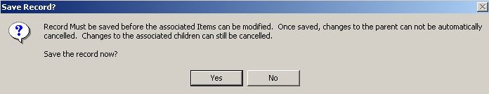
Figure 5-33 – Sample message boxA message box similar to the one in sample Figure 5-33 may appear.

- Click on Yes the save the selected facilities to the group you created.

The selected facilities are moved to the Facilities Included listbox.

- Click on the Save button to complete the process.

Editing Reporting Groups
- Select the reporting group you need to edit and click the Edit button.

The Group Name field will be selected for editing.

Click in the field(s) you need to edit and make the required change.

You can remove one or more facilities from a group as follows:

Method 1
- Hold down the <CTRL> key and click on each facility you want to exclude.

- Click on the move button .

Method 2
- Click on the first facility you want to include.

- Scroll down to the last facility you want to include.

- Hold down the <Shift> key and click on the last facility you want to exclude.

- Click on the move button .

- Click on the Save button to complete the process.

Deleting a Reporting Group
- Select the Reporting Group you want to delete.
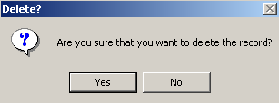
Figure 5-34 – Deletion confirmation message
- Click on the Delete button.

A confirmation message similar to the sample in Figure 5-34 is displayed.

- Click on the Yes button to delete the selected report group.

- Repeat steps 1 – 4 to delete additional reporting groups.

- Click on the Close button when you finish deleting Reporting groups.

